SQL PROJECT QUERIES

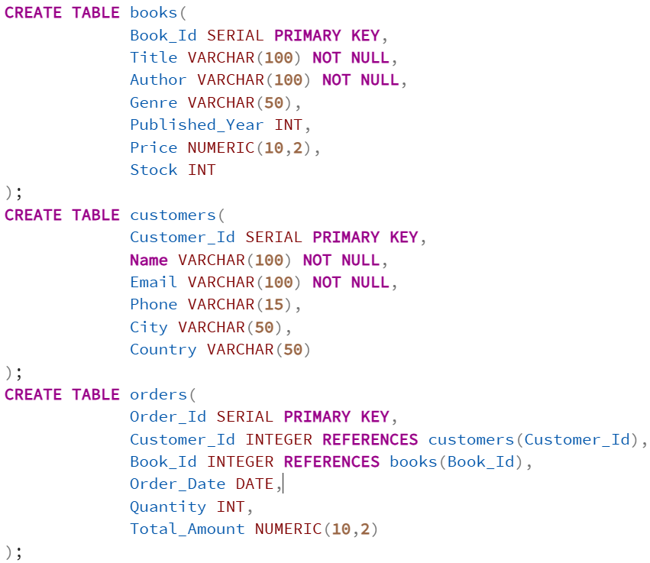



BASIC QUERIES
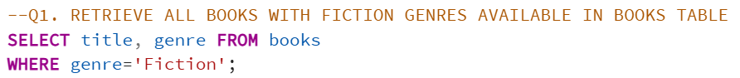
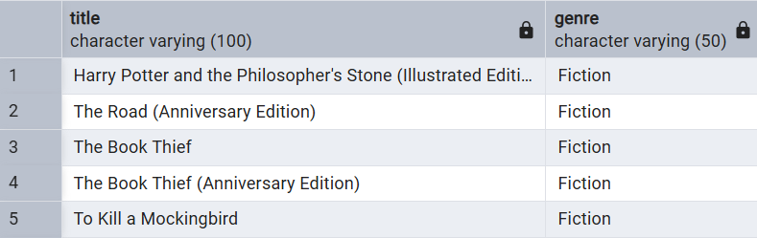
Query Output – The query returned 51 records. A sample of the resulting records is shown above.

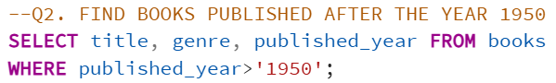
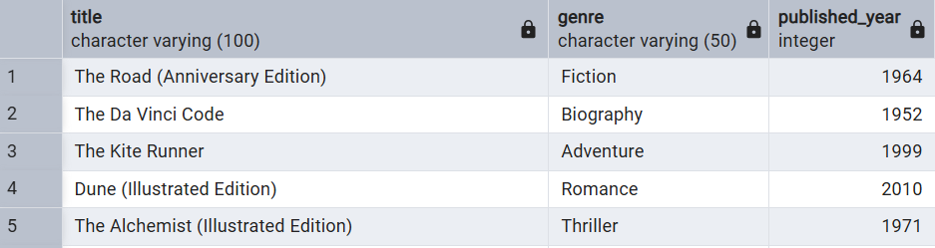
Query Output – The query returned198 records. A sample of the resulting records is shown above.


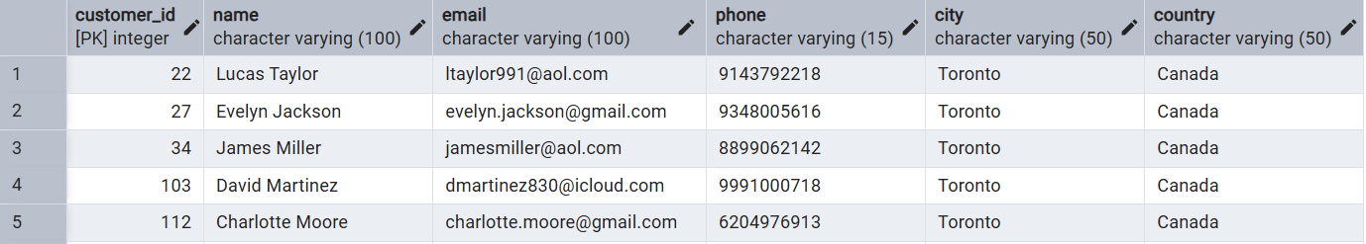
Query Output – The query returned 26 records. A sample of the resulting records is shown above.

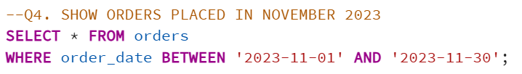
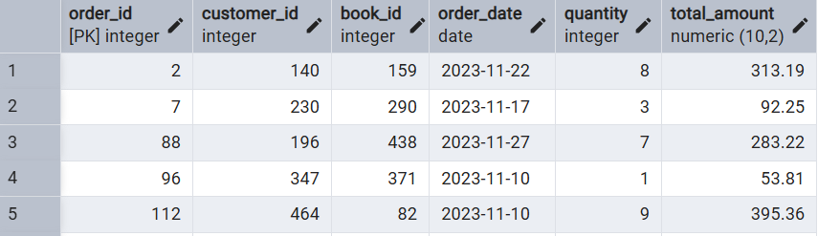
Query Output – The query returned 22 records. A sample of the resulting records is shown above.

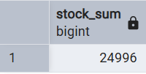

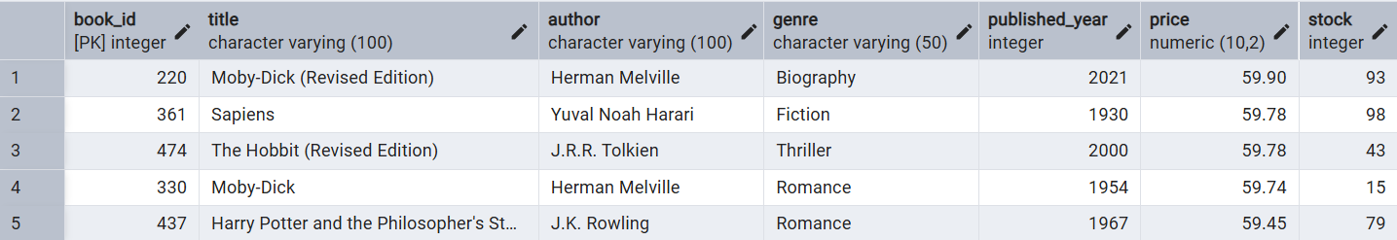

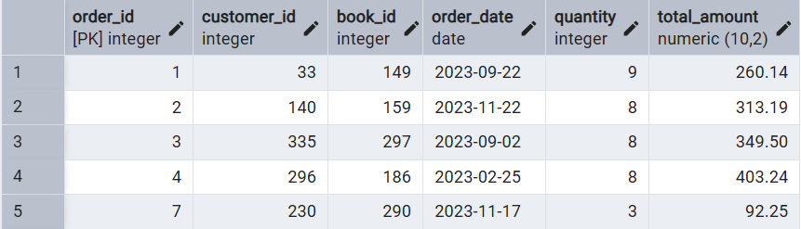
Query Output – The query returned 449 records. A sample of the resulting records is shown above.

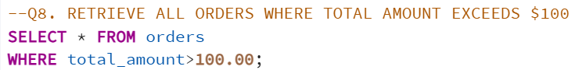
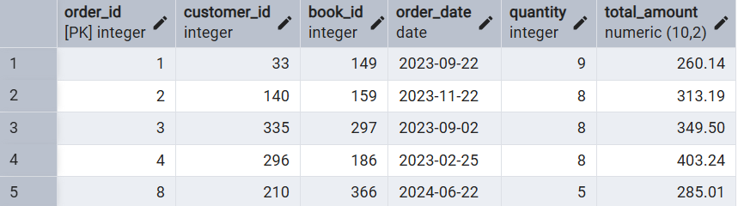
Query Output – The query returned 315 records. A sample of the resulting records is shown above.


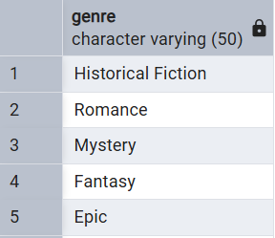
Query Output – The query returned 14 records. A sample of the resulting records is shown above.

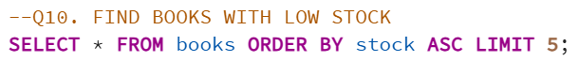
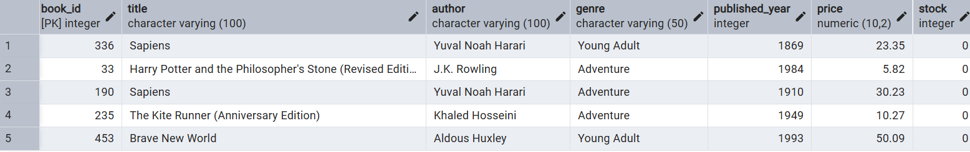

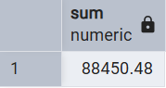

ADVANCE QUERIES
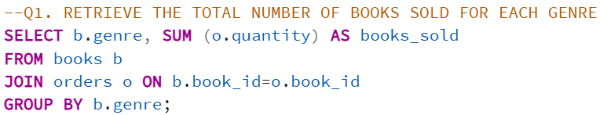
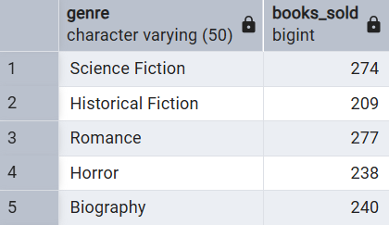
Query Output – The query returned 13 records. A sample of the resulting records is shown above.


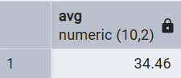

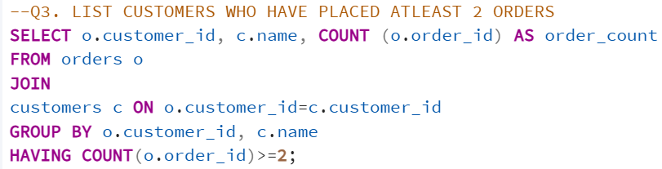
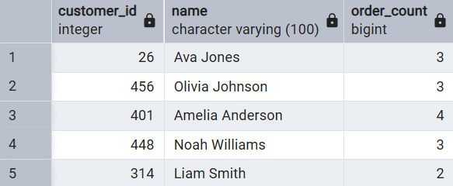
Query Output – The query returned 135 records. A sample of the resulting records is shown above.

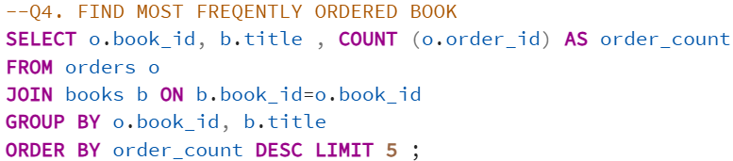
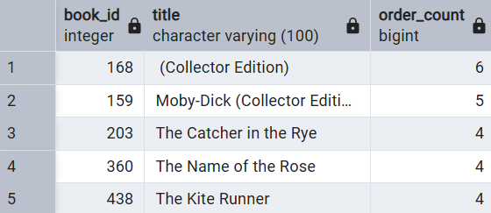
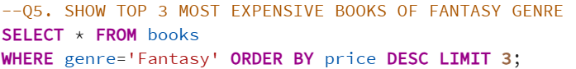
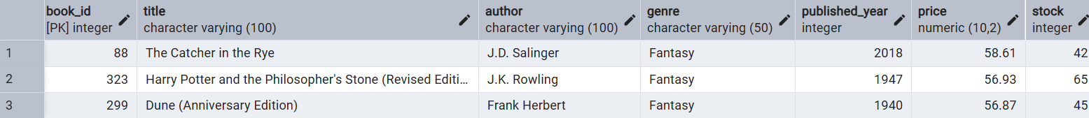

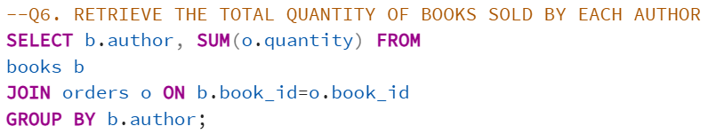
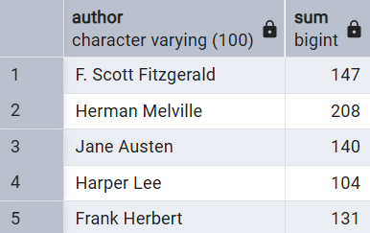
Query Output – The query returned 21 records. A sample of the resulting records is shown above.

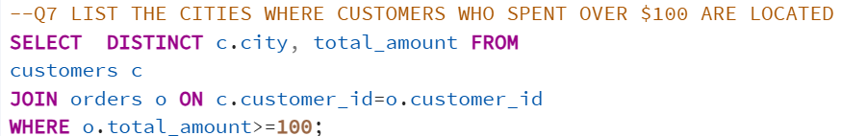
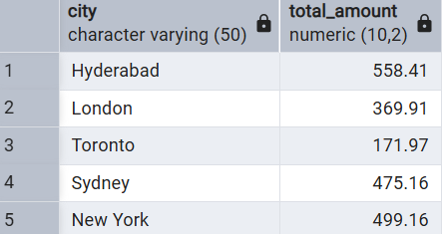
Query Output – The query returned 315 records. A sample of the resulting records is shown above.

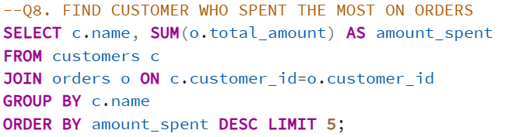
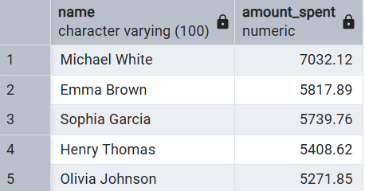

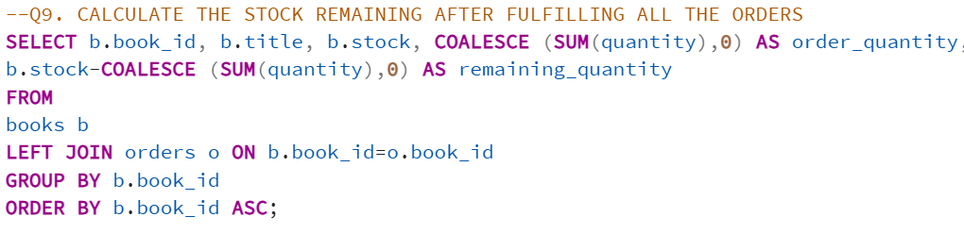
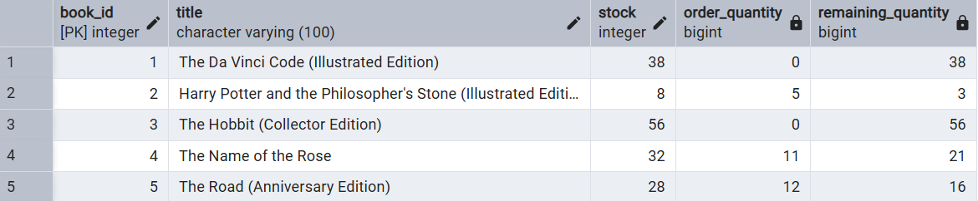
Query Output – The query returned 500 records. A sample of the resulting records is shown above.

